SYMBOLIC ARM CASTING
- Use this template to plan out your arm casting design. Feel free to come up with more than one blueprint. Your design can evolve and change through-out the process.

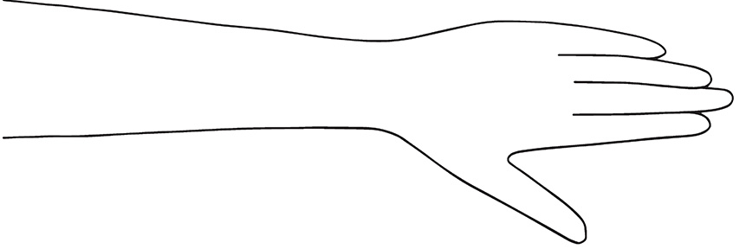
- Use the space below to also explain your design and the symbolism behind your concept. Take inspiration from the online lesson and attached links along with your own life and story. What make you…you?
Theme Ideas to get you started:
Heritage, culture, religion, zodiac, family, goals, strengths, animals, hobbies, characteristics, emotions, books, idols, paintings

