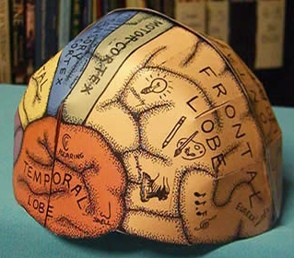
GET YOUR THINKING CAPS READY!
In this lesson you will create a thinking cap that you can wear! It’s your job to decorate it in your own personal style and you can select one of two choices:
- A non-labeled brain: Create what’s in your very own personal brain. A 3-D Mind map. Create color and personalize a blank brain cap. What makes you…you? You can be creative, inventive and craft your own brain functions and personality traits. What are your strengths and weaknesses and where do they reside in your brain?

- A labeled brain: Create and color a brain cap with the proper labeling that scientifically demonstrates and describes where certain brain functions and personality traits reside.

NOTE! Use the same colors on both sides of the brain to demonstrate symmetry and balance.
Remember you need a WHOLE-BRAIN to do well in school!
Materials:
- Scissors, Staples, Tape, Glue
- Paper clips to hold lobes together while in drying process if glue is used.
- Coloring supplies – markers, crayons, colored pencils
- Card stock paper to print templates
- Brain Templates: http://www.ellenjmchenry.com/homeschool-freedownloads/lifesciences-games/documents/Brainhat.pdf
- Quiz handout: http://soular00t.tumblr.com/post/47637845316/right-or-left-brained
All information can also be found on Mrs. Groenstein’s AAE art website under all age projects. http://aaeart.weebly.com/brain-inventory-thinking-cap.html This lesson is inspired by: http://www.ellenjmchenry.com/
___________________________________________________________________________________
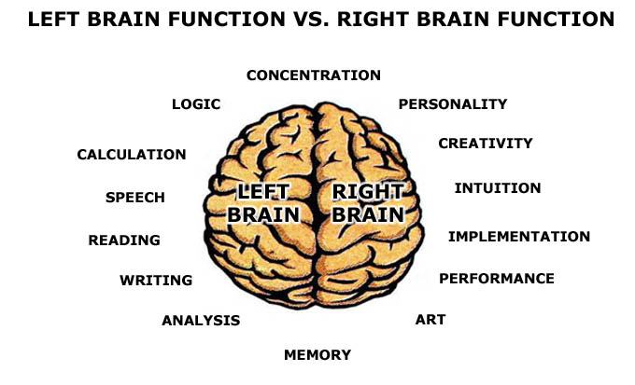
BRAIN BASED INVENTORY

Understanding which side of your brain is more dominant can totally transform the way you learn in the future and develop your strengths and help work on your weaknesses. Although it doesn't take a rocket scientist to figure out which side is more dominant than the other you can use the attached diagram to help you. Keep in mind you need both sides of your brain to successfully function. The idea is to reinforce whole brain learning and recognize the creative process (a right brain function) also needs left brain cognitive thinking skills and vice-versa.
Whole brain learning is the balance of both the right and left brain ways of thinking that allow us to understand, frame and problem solve. While "left brain" thinkers refer to the more logical, analytic and rationale in contrast with the "right brain" skills which are creative artistic and emotional, whole brain process possess the ability to apply both ways of thinking to the problems they solve.
Today's challenges in the engineering world require a combination of technical expertise, the ability to innovate, and the skills to develop and implement complex solutions. These demands call for whole-brain engineers and developing core analytical skills while augmenting them with the "right-brain" thinking through the design process and personal activities.
RIGHT-BRAINED DOMINANT PEOPLE – If you are right-brained, you are usually more artistic, than scientific. Your favorite subjects are probably English, Arts, or Music. You enjoy games like Charades and Pictionary – activities that utilize the creative part of your brain to get your point across, or to assimilate information. Now we realize that most kids aren't thrilled about cleaning their rooms but a right-brained person can really keep things messy. They can have piles of things all over the place, but they defend them as “organized” piles and somehow know exactly where to find their stuff.
LEFT-BRAINED DOMINANT PEOPLE – If you are left-brained, you like things a little more organized. Math and science are usually your favorite, or least challenging subjects. You rock on a True/False test and almost always read directions so you know exactly what to do. Your favorite games are word or number puzzles and Jeopardy. You like games with exact answers. You might even be one of the only kids in the world that like to have a clean room.
Still not sure which part of the brain is more dominant and describes your strengths and personality? Take the right brain vs. left brain quiz to find out just to be sure or go to the online quizzes that are on Mrs. G. website. You can find it under all age projects with the subject being “brain inventory”.

