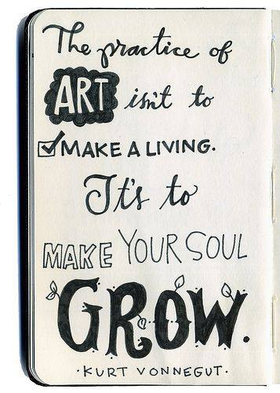
SKETCH BOOK GOALS and OBJECTIVES
Overview: The purpose of the sketchbook in the art class should serve as documentation or a body of evidence of the student’s artistic growth. It should reflect the creative process and provide the student and teacher with a more holistic perspective to the student’s knowledge and understanding of art.
Objectives:
- Refine and complete artistic artwork: Apply relevant criteria to examine, reflect on, and plan revisions for a work of art or design in progress
- Organize and develop artistic ideas and work: Demonstrate willingness to experiment, innovate and take risks to pursue ideas, forms and meanings that emerge in the process of art making or design.
- Generate and conceptualize artistic ideas and work: Document early stages of creative process visually and or verbally in traditional or new media.
EXPECTATIONS: (What should be in your sketchbook binder): The drawings you are assigned are the pathways to developing new ideas on your own. Take risks and take them further. DO NOT THROW AWAY YOUR MISTAKES! They are a part of growth and show progress.
SKETCHES:
- Sketches and assignments neatly in order they were given - either in three ring binder or bound sketchbook.
- Mistakes. Improvements. Revisions of class sketchbook and studio assignments.
- Extra credit/drawing assignments/ drawings from observation.
NOTE TAKING:
- Reflections and Annotations: Annotate/describe artistic process of assignment. Was it difficult? Was it easy? Why? What were your strengths, what were your struggles?
- Artistic styles, elements and principles of design: Media practices, art vocabulary. What elements or principles were used? Time period, artist we discussed or an artist you discovered with the same style? What art media did you use, experimental techniques?
- Research: Was there research involved? Record, reference and acknowledge sources of information. What pertinent information did you discover? What did you learn that you did not know before? Compare and contrast artwork. Others or your own. Citation of evidence, ex: articles, website, books.
ASSIGNMENT: | Due week of: | Completed
- Purchase a three ring binder for art class to house all of your art handouts and drawings. This can be combined with other Encore classes but NOT core. Buying an actual sketchbook is optional as I have an endless supply of paper in my classroom. You will have to 3 hole punch lose leaf paper or use plastic paper sleeves. Decorate cover/outside of binder. | Sep 6th
- A few things about you: Make an inside cover page to reflect and express your personality. Words and images. | Sep 12th
- What is art? What goals do I have for myself in Visual Arts? Drawing with words. (MIND MAP) Use description and detail. | Sep 19th
- Portrait - Draw yourself from life using a mirror. | Sep 26th
- Intuitive Art - Use your skills from last year. Allow the images to flow out without thought. | Oct 3rd
- Draw a birds-eye view of your feet. | Oct 10th
- Rock. Paper. Scissors. Draw your hands. Show as much detail as possible. Create 3 different versions. DO NOT TRACE YOUR HAND | Oct 17th
- Draw at least three different versions of trees. Take it further and do branch studies, creating implied texture and demonstrating shading. | Oct 24th
- Create a sphere/egg/apple using value. Make more than one: 1- Black and Grey, 1- Color, 1 - with a ball point pen. We will be doing this one again! | Oct 31st
- Practice using lines to create value. Create three different value scales using different types of lines. The more lines you gather together and the closer the lines are to each other, the darker the value (shade) appears to be. | Nov 7th
- Do a study of something that shows implied texture and value, such as a pillow or crumpled up piece of paper. | Nov 14th
- Find an object such as a stapler, glue container, spray bottle, scissors, hairbrush, hammer, shoe, etc. and create multiple thumbnail size views. | Nov 28th
- ENTIRE SKETCH BOOK TO BE COLLECTED WITH ALL ASSIGNMENTS WEEK OF NOV 3oth!! Extra drawings, free drawing, concentration work, planning, design process and notes are all ideal to have in your books to show evidence of growth. | Dec 12th
SKETCHBOOK ASSIGNMENTS: Students are required to practice drawing for at least a half hour per assignment! One assignment will be given per week. You are encouraged to write reflections with your images. To become better at drawing you must practice!

